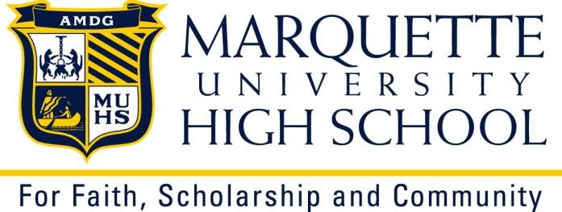

MARQUETTE UNIVERSITY HIGH SCHOOL

Job Title: Head Men’s Varsity Wrestling Program Coach
Job Start Date: September 2023
Application Closing Date: until filled
2023-24 salary: competitive, dependent upon years of experience.

Position summary: The wrestling coach provides visionary and motivating leadership for the MUHS wrestling program. S/he will develop and execute short and long-range goals for the program and ensure a cooperative, supportive, and challenging environment for student-athletes. Adherence to policies and standards is required. S/he will direct and supervise a staff of coaches. Positive role modeling that provides focus on the mission of Marquette University High School and athletics for the development of good sportsmanship, leadership qualities, and personal and team growth is expected. The ability to promote the program to students, parents, faculty and administration is important. Monitoring student-athlete academic performance is required.

Position description:
In Season duties:
- Prepare and/or supervise the preparation of season, weekly and daily practice plans as well as workouts on all levels.
- Provide information, communications, sign ups, forms on file, etc. Work closely with the MUHS Athletic Director.
- Oversee, direct and supervise all coaches.
- Develop the whole program on all levels including novice wrestlers.
- Know, understand and apply all WIAA swim rules pertaining to wrestling. Always know and understand Greater Metro Conference guidelines.
- Manage wrestling operations in our practice facility.
- Capture, maintain and utilize MUHS athlete performance video or other technology when possible.
- Manage all wrestling operations including, but not limited to, the purchase and maintenance of equipment.
- Maintain athlete’s in-season strength program.
- Participate in post season conference meetings, etc.

Out of Season duties:
- Encourage the students of MUHS to participate in wrestling and provide information to the general student population as to the benefits of the program.
- Prepare season non-conference contest schedules with MUHS AD.
- Adhere to WIAA out of season allowances.
- Advocate and supervise out of season strength training, conditioning, and speed work.
- Brainstorm with coaching staff for team development, training theory, etc.
- Participate in facilities management and budget requests with AD.
- Maintain inventory of equipment and uniforms, purchasing new equipment and uniforms when necessary.
- Maintain membership in wrestling professional organizations.
- Seek out opportunities for professional development.

Supervision Received: This position reports directly to the Athletic Director

Working Environment: This is a winter athletic season position with out of season expectations. It will require evening and weekend work and travel to different locations.

This description documents the general nature and level of responsibility associated with this position. It is not intended to be a comprehensive list of all activities, duties, and responsibilities required. It is not intended to limit or modify the right of any supervisor to assign, direct, and monitor the work of employees under supervision.
How to apply: If you are interested, please send your cover letter, resume and contact list of references to:
MARQUETTE UNIVERSITY HIGH SCHOOL
Attn: Bob Herman, Athletic Director
herman@muhs.edu
3401 W. Wisconsin Avenue, Milwaukee, WI. 53208
Phone: 414-933-7220 | Fax: 414-933-3086

OR

E-mail: jobs@muhs.edu | School Website: http://www.muhs.edu

