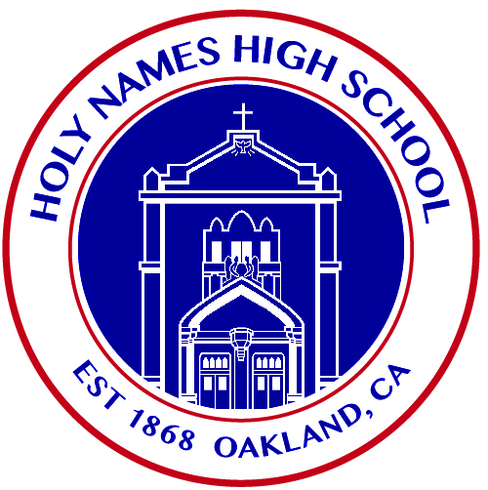

THEOLOGY TEACHER
Holy Names High School is a small Catholic school for young women, is seeking a full time Theology teacher to join our amazing faculty for 2022-2023 school year. The Theology Teacher fulfills the mission of the Catholic school by planning and guiding the learning organization, and curriculum. The Teacher provides the appropriate learning atmosphere and activities designed to maximize student competencies and skills for intellectual, emotional, physical, social, and spiritual growth toward a successful future. The teacher has decision-making responsibilities within essential job functions, in keeping with school policies. Holy Names High School serves a culturally, linguistically, and socioeconomically diverse student body. Our faculty/staff share a genuine commitment to all young women and support the Holy Names mission, vision and strategic plan. The Theology teacher reports directly to the Principal.
Job Summary:
- Supports and upholds the philosophy of Catholic education and the mission of the school
- Acts as a witness to Gospel values by modeling the teachings of the Catholic Church
- Supports and adheres to the Code of Conduct and policies and procedures of the school and Diocese
- Maintains confidentiality regarding school matters
- Plans for instruction with logically sequenced objectives, based on adopted curriculum and submitted according to the local school policy
- Provides appropriate material and resources for students to engage in learning
- Uses effective instructional methods/models according to professional standard practice
- Uses varied assessment tools to perform both formative and summative assessments
- Provides instruction and assessment for understanding
- Communicates with parents regarding academic, behavioral, or safety concerns
- Meets staff development guidelines as set forth by the Diocese/local administration and attends weekly staff meetings
Recommended Qualifications:

Education/Certification:
- Certification in Religion/Theology and/or Bachelor’s degree in Theology

Salary is paid commensurate with experience and education.

Please send resume to ctatman@hnhsoakland.org

