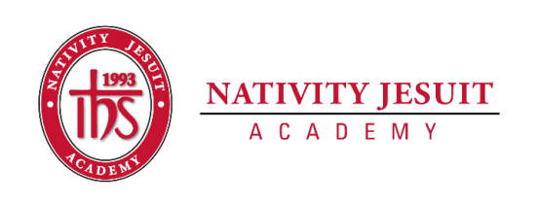
Updated March 2024
Open Position: School Program Coordinator

Position Type: Full time Monday-Friday, 8:30am-5:15pm (weekends if needed)

Start Date: July 1, 2024

Equal Employment Opportunity:
Nativity Jesuit Academy is an equal opportunity employer.

About Nativity Jesuit Academy:

Nativity Jesuit Academy (NJA) is a K4-8 co-ed Catholic, Jesuit, urban school serving young men and women in Milwaukee, WI. We prepare our students, in partnership with their families, for Christian leadership and service in high school, college, and life.

Through a holistic education program, NJA strives to form leaders who are religious, loving, seeking intellectual excellence, committed to justice and open to growth. Like Christ, who came “not to be served, but to serve” (Mark 10:45), NJA transforms students to become men and women for and with others.
Position Summary:
The school program coordinator will oversee the after-care instructor, all after-school activities, and coordinate all programs after school while working closely with the Assistant Principal, Front Office Manager, and Facilities Manager.

Position Responsibilities:
- Manage sports and extracurriculars with support from school leadership team
  - Point of contact for coaches
  - Lead parent and student meetings related to after-school activities
  - Create and manage athletic calendar
  - Build partnerships with community members and programs to bring new activities to Nativity
  - Manage communication to families regarding extracurriculars in conjunction with the front office

- Athletic Coordinator duties will include, but are not limited to:
  - Attend League Meetings (evenings)
  - Manage sign up, rostering, (including collection of sports fees) and scheduling of all teams
  - Attend practices and games as needed
  - Manage the maintenance and purchasing of uniforms
  - Work closely with our facilities manager to manage the gym for home games and any other after-school activities
  - Manage Athletic budget & manage all calendars for sports

- Manage all parent and student volunteers
  - Train volunteers
  - Ensure volunteers meet all compliance requirements
  - Coordinate, schedule and communicate volunteer duties with all stakeholders

Position Qualifications:
- 18 yrs of age or older.
- HS Diploma or GED
- At least 1-year experience working with children, preferred.
- Enjoy working with children.
- Required Trainings
  - Current CPR/AED certification (ability to successfully complete CPR/AED, new employee only!)
  - Safe Environment training (Upon hire)
- Spanish speaking (preferred)
Skills, Knowledge, Abilities:
- Ability to problem-solve
- Ability and willingness to participate and engage children in all program activities
- Ability to communicate effectively with children (ages 4-14 years old), staff and parents
- Possess quality of patience, flexibility, understanding, acceptance, and care.
- Ability to supervise and manage groups of children following developmentally appropriate practices
- Enjoys working with children

How to Apply:
- Send resume, cover letter, and three references to Ally Beckwith, Assistant Principal at beckwitha@nativityjesuit.org.
In the cover letter, address the following questions:
● What influenced you to work in schools?
Applicants that do not include a resume, cover letter, and three references will not be considered a complete application and will not be reviewed.

