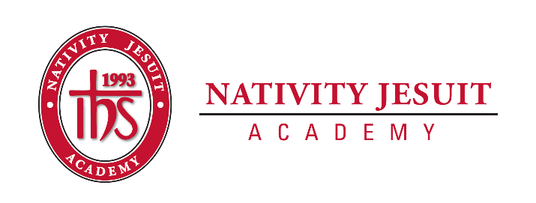
Camp Thunderhead
An Extension of Nativity Jesuit Academy

Open Positions: Camp Thunderhead Staff Member

Position Type: Seasonal

Start Date: June 12, 2022

Equal Employment Opportunity:
Camp Thunderhead, LLC is an equal opportunity employer.

About Camp Thunderhead, Northern WI Campus:
Camp Thunderhead is a five-week academic residential summer camp situated in Wisconsin's great Northwoods. Camp Thunderhead is accredited by the American Camping Association. Located north of Mercer, Wisconsin, the camp program and experience is unique, rewarding, and transformational in its commitment to and service of the Latino students from the Milwaukee area.

Camp Thunderhead is an extension of Nativity Jesuit Academy. The camp serves to expand the Nativity Jesuit academic school year which focuses on educating youth for a life of Christian leadership and service.

While at camp, students attend morning classes of reading, science, and math. Each afternoon, students participate in environmental education, learn woodworking skills, swim, play sports, learn outdoor living skills, and much more. Students gain both academic knowledge and life skills at camp while growing strong in the mission of Nativity Jesuit.

Camp Thunderhead provides both students and staff an ideal setting for a variety of learning experiences and collaborative leadership development as well as community building opportunities as students live together in cabins and grow, learn, lead, and serve each other in a positive and safe learning environment.

About Nativity Jesuit Academy, Milwaukee Campus:
Nativity Jesuit Academy is a K4-8 co-ed Catholic, Jesuit, urban school serving young men and women. We prepare our students, in partnership with their families, for Christian leadership and service in high school, college, and life. The school is located in Milwaukee, Wisconsin.

Through a holistic education program, Nativity Jesuit strives to form leaders who are religious, loving, seeking intellectual excellence, committed to justice, and open to growth. Like Christ, who came “not to be served, but to serve” (Mark 10:45), Nativity Jesuit transforms students to become men and women for and with others.
OVER

Position Summary:
As a Camp Thunderhead employee, you have the opportunity to teach classes, coach sports, plan and lead activities, develop life skills, and form meaningful bonds with students and staff. Our staff is dedicated and inspirational. These leadership and multi-cultural opportunities provide great resume-building experiences.

Position Responsibilities:
- Camp employees live at camp while working the entire duration of the Camp Program, including during the required Staff Orientation. Arrangements for local-area staff members can be made.

Position Requirements:
- Camp staff members and teachers must be available for the following dates:
  - Staff Orientation (required): June 12-June 20, 2022
  - Camp Sessions: June 20-Aug 2, 2022
- At least 18 years of age
- At least one year of college completed
- Willingness and capability to work and serve as a positive role model in a positive, mission-driven, healthy, and safe camp educational environment
- Teaching/tutoring/coaching experience and/or multi-cultural experience is preferred but not required

If applying for the Camp Teacher position:

- Applicant must have earned a Bachelor’s Degree
- Preferred: Education-based field and/or Teaching Certification

Compensation and Benefits:
- Benefits include: free room, board, and meals; breaks/free-time
- Competitive starting salary with annual salary increases for returning staff
- Additional compensation for current certifications/licenses
- CPR and First Aid Training will be provided (2-year certification)
- Reimbursement available for Lifeguard Certification (optional)

How to Apply:
- Email Camp Director Joshua Kraemer at kraemerj@nativityjesuit.org
- Please include any relevant prior work experience and also all current certification(s)
- If applying for the Teacher position, please include a copy of your bachelor’s degree and/or proof of your teaching certification
- Job applications are being accepted now and will be reviewed in the order they are received. Applicants are encouraged to submit applications as soon as possible.

