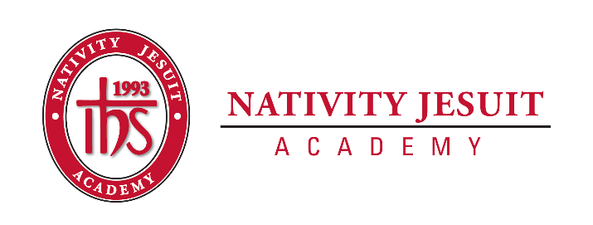
Camp Thunderhead
An Extension of Nativity Jesuit Academy

Open Position: Summer School Camp Cook

Position Type: Seasonal

Start Date: June 12, 2022 *prior workdays for preparing required: early June dates TBD

Equal Employment Opportunity:
Camp Thunderhead, LLC is an equal opportunity employer.

About Camp Thunderhead, Northern WI Campus:
Camp Thunderhead is a five-week academic residential summer camp situated in Wisconsin's great Northwoods. Camp Thunderhead is accredited by the American Camping Association. Located north of Mercer, Wisconsin, the camp program and experience is unique, rewarding, and transformational in its commitment to and service of the Latino students from the Milwaukee area.

Camp Thunderhead is an extension of Nativity Jesuit Academy. The camp serves to expand the Nativity Jesuit academic school year which focuses on educating youth for a life of Christian leadership and service.

While at camp, students attend morning classes of reading, science, and math. Each afternoon, students participate in environmental education, learn woodworking skills, swim, play sports, learn outdoor living skills, and much more. Students gain both academic knowledge and life skills at camp while growing strong in the mission of Nativity Jesuit.

Camp Thunderhead provides both students and staff an ideal setting for a variety of learning experiences and collaborative leadership development as well as community building opportunities as students live together in cabins and grow, learn, lead, and serve each other in a positive and safe learning environment.

About Nativity Jesuit Academy, Milwaukee Campus:
Nativity Jesuit Academy is a K4-8 co-ed Catholic, Jesuit, urban school serving young men and women. We prepare our students, in partnership with their families, for Christian leadership and service in high school, college, and life. The school is located in Milwaukee, Wisconsin.

Through a holistic education program, Nativity Jesuit strives to form leaders who are religious, loving, seeking intellectual excellence, committed to justice, and open to growth. Like Christ, who came “not to be served, but to serve” (Mark 10:45), Nativity Jesuit transforms students to become men and women for and with others.
OVER

Position Summary:
As a Camp Thunderhead employed Cook, you have the opportunity to manage the operation of the kitchen and dining hall - order, prepare, and serve the meals, maintain the kitchen and dining hall for service, and collaborate with other camp staff in order to provide the food service.

Position Responsibilities:
- Camp employees live at camp while working the entire duration of the Camp Sessions. Arrangements for local staff members can be made.
- Additional workdays both prior to and after the camp session will be required for the Camp Cook to order food, set up and close down the kitchen and dining hall. These dates and duties will be determined with the Camp Director.
- Camp Cook organizes and prepares meals for the Staff Orientation and the duration of the camp session. There are approximately 30 students/session and 20 staff at camp.

Position Requirements:
- Camp cook must be available for the following dates:
  - Staff Orientation (required): June 12-June 20, 2022
  - Camp Sessions: June 20-Aug 2, 2022
  - And additional dates as determined by the Camp Director
- At least 21 years of age
- Must possess or be willing to obtain prior to employment start date: current Wisconsin Department of Health approved Food Service Manager Certification (contact camp Director for more details)
- Must order, prepare, serve and maintain all food/menu items in compliance with state-mandated Summer School Food Program nutrition guidelines
- Willingness and capability to work and serve as a positive role model in a positive, mission-driven, healthy, and safe camp educational environment
- Prior cook experience, working in a school/camp food service preferred but not required

Compensation and Benefits:
- Benefits include: free room, board, and meals; breaks, time-off days
- Competitive starting salary with annual salary increases for returning staff

How to Apply:
- Email Camp Director Joshua Kraemer at kraemerj@nativityjesuit.org
- Please include any relevant prior work experience and also all current certifications
- Obtaining the required Food Service Manager certification requires enrolling in class/passing an exam – this process takes time and should be started promptly
- Job applications are being accepted now and will be reviewed in the order they are received. Applicants are encouraged to submit applications as soon as possible.

