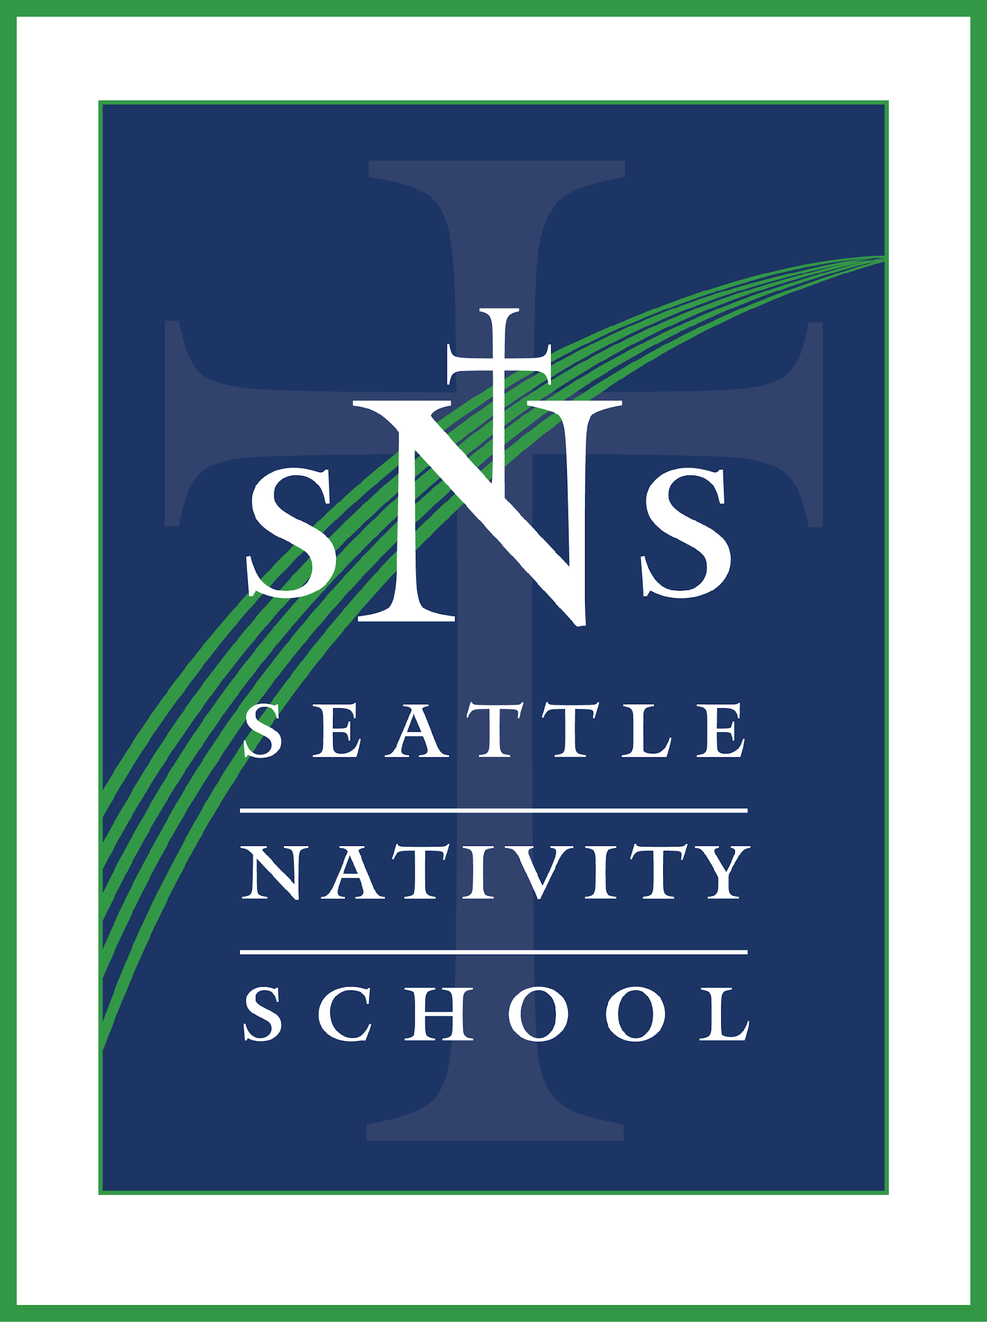
SEATTLE NATIVITY SCHOOL
Nourishing Souls & Igniting Leaders for Love and Service

Position
Teacher of Mathematics (grades 6th, 7th, and 8th)

The School
Seattle Nativity School is a Catholic, Jesuit-endorsed STEM (science, technology, engineering and math) middle school seeking to break the cycle of poverty through an education that nourishes souls and ignites leaders for love and service. The school opened its doors in September of 2013 to its first class of 6th graders. Seattle Nativity School serves low-income youth in 6th through 8th grade, offering a challenging and supportive learning environment to motivate students of all faiths. We strive to graduate young men and women for others who are: intellectually competent, open to growth, committed to justice, religious, loving, and grateful.

When
Starting with the opening of the August 2024 teacher in-service days and continuing through the 2024-2025 academic school year.

Position Description
The Mathematics Teacher will work with colleagues to develop and implement a rigorous, cross-curricular Math Curriculum for 6th, 7th, and 8th grade students.

Responsibilities
- Teach Mathematics to the 6th, 7th, and 8th grade students, including Algebra I to 8th graders.
- Create a supportive and caring classroom environment in which students can learn and interact positively with one another, through student-centered instruction, collaboration, and assessment.
- Implement a standards-based, academically rigorous curriculum targeting remediation and grade level proficiency.
- Utilize data-based best practices, formative, and summative assessments, diverse teaching methods, technology, and differentiation to provide effective and engaging instruction.
- Monitor students in a variety of educational settings (e.g. classroom, school grounds, hallways, lunchroom, restrooms, field trips, study hall/after school, etc.) to provide a safe and positive learning environment.
- Communicate effectively with the administration, colleagues, and volunteers, parents and/or legal guardians.
- Serve as a positive faith-based role model for students and families.

Recommended Qualifications
- A dynamic teacher with a proven track record of successful middle-level instruction for urban youth.
- Ability to work proactively, collaboratively, inclusively, and respectfully with others.
- Keen understanding of the flexibility and innovation required in a startup school.
- Excellent oral and written communication skills.
- Experience working with diverse students and communities facing economic and social challenges.
- Hold a Bachelor’s degree (Master’s preferred).
- Hold a valid teaching certificate.
- Have experience using technology within the classroom.
- Demonstrate a commitment to social justice.
- Ability to develop and implement a learning environment promoting Catholic Identity.
- Enthusiastic commitment to the Jesuit tradition of education and the mission of Nativity Schools.
- Practicing Catholic preferred.

Clearances
Criminal Justice Fingerprint/Background Clearance as well as ongoing Safe-Environment Training with the Seattle Archdiocese.

Compensation
Competitive and commensurate with experience.

How to apply
Interested candidates please send resume and cover letter to: Ms. Bei Bernal, Principal, bbernal@seattlenativity.org

Location
Seattle Nativity School
4200 S. Mead St.
Seattle, WA 98118

