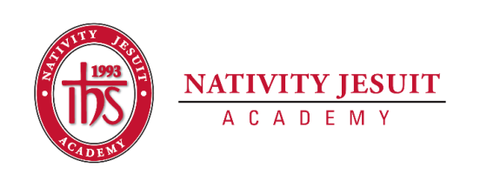
Updated March 2022

Open Position: 4th-5th Grade English Language Arts (ELA) Teacher-Long Term Substitute

Position Type: Full Time

Start Date: August 10, 2022

Estimated End Date: November 23, 2022

Equal Employment Opportunity:
Nativity Jesuit Academy is an equal opportunity employer.
About Nativity Jesuit Academy:
Nativity Jesuit Academy is a K4-8 coed Catholic, Jesuit, urban school serving young men and women in Milwaukee, WI. We prepare our students, in partnership with their families, for Christian leadership and service in high school, college and life.

Through a holistic education program, Nativity Jesuit strives to form leaders who are religious, loving, seeking intellectual excellence, committed to justice and open to growth. Like Christ, who came “not to be served, but to serve” (Mark 10:45), Nativity Jesuit transforms students to become men and women for and with others.

Position Summary:
This position is to cover maternity leave from August of 2022 until the Thanksgiving Break. The 4th-5th Grade ELA Teacher is responsible for integrating reading, writing, and language curriculum using the “Common Core State Standards.” This position is also responsible for teaching one section of 5th grade social studies and one section of 5th grade religion, as well as being the 5th grade homeroom teacher. NJA leverages a blended learning platform to help reach all students. The ELA Teacher differentiates lessons in order to reach and challenge all students. The ELA Teacher is successful by demonstrating objective-driven instruction, high expectations, accountability for students, and rigorous student engagement. Working on a 4th and 5th grade team, the ELA Teacher communicates effectively with colleagues and parents.

Position Responsibilities:
- Committed to the school’s mission as a Christian servant leader.
- Strong organization skills and preparedness to teach assigned classes.
- Work with colleagues to ensure daily instructional curriculum meets the state teaching standards.
- Teach engaging and challenging units of study while providing rigorous assessments.
- Committed to all pedagogical and school culture responsibilities involved with implementing blended learning.
- Attend all professional development meetings and enrichment opportunities.
- Ensure that all assessments are administered and graded in a timely manner; maintain accurate student records; analyze results with staff, parents, and students; make adjustments to instruction, as needed.
- Complete quarterly report cards and conduct parent conferences.
- Partner with families during the school day and in other school events to build a working relationship with each family.

Position Qualifications/Characteristics:
- Appropriate DPI educator’s license obtained or in the process of obtaining/transferring educator’s license
- Minimum of a bachelor’s degree

Preferred:
- Catholic
- Spanish speaking
- Three years of relevant teaching experience

How to Apply:

Send résumé and cover letter to Jon Nowak, Principal, at nowakj@nativityjesuit.org

