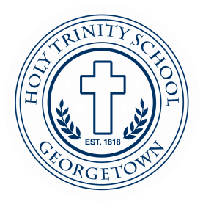
Holy Trinity School, a Catholic elementary school in the Jesuit Tradition, seeks an innovative and collaborative Athletic Director/Head PE teacher to join our administration and faculty for the 21-22 SY to lead, manage and promote the CYO and physical education programs that include logistical coordination of athletic facilities, schedules, officials, coaches, as well as physical education curriculum development and implementation. The successful candidate will work as part of a dynamic, high-energy educational team and will have strong interpersonal, communication, and organizational skills. Some of the duties and responsibilities include: Teaching content and skills in physical education to Pre-K – 8th grade; providing appropriate safety instruction and supervision at all times; and organizing and overseeing the school’s CYO program. Qualifications: Bachelor’s degree in a related field, minimum and teaching experience; Certified to teach in MD, DC, or VA or is willing to gain certification within three years; and demonstrates strong writing and communication skills, a capacity for organization and follow-through, collaboration, and flexibility. Further information may be found at: Jobs at Holy Trinity | Holy Trinity Catholic Church
How to apply: Send cover letter and resume to Angela Grady at agrady@htsdc.org. Please include the position title in the subject line.

