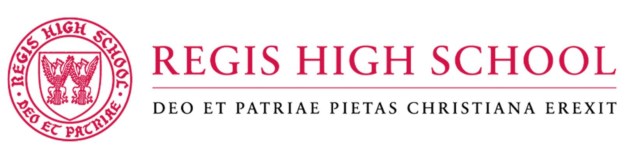
Mission Statement

Regis High School transforms Catholic young men through an academically exceptional Jesuit education in a caring community which inspires leadership, generosity, and a lifelong passion for service as Men for Others. Regis is tuition-free, and merit-based, giving special consideration to families in need of financial assistance.

Position
As an English Teacher, you will have the extraordinary opportunity to work with approximately 530 exceptional young men, talented faculty, and dedicated staff. Located in New York City, Regis High School is a Catholic, Jesuit, college preparatory school and the only Jesuit, full-scholarship high school in the country.

The school was founded in 1914 through the extraordinary generosity of an anonymous woman and her family. Regis now thrives on the philanthropy of alumni, parents, and friends as its most significant source of financial support. Regis prioritizes academic excellence while nurturing a spirit of generosity and service to those in need. Regis aspires to inspire and educate a diverse student body, nurturing them into imaginative Catholic leaders committed to promoting justice and exerting influence in the Church, their civic community, and their chosen profession.

Position Summary
Regis seeks a qualified candidate to join its faculty as an English Teacher for the 2024-2025 Academic Year. This is a full-time faculty position. Position comes with full benefits. Work hours may vary and will include some evenings and weekends for special school events. Salary is very competitive for the New York City area and is commensurate with experience. The 2024-2025 school year begins for new faculty members at the end of August 2024 and concludes June 13, 2025.

Job Responsibilities
- Position may include teaching a 9th grade through 11th grade curriculum, and a 12th grade elective course of the teacher’s choosing.
- Will perform services that include the preparation of examinations, the correction and assignment of grades and assigned proctoring.
- Will be generally available to the students in one’s assigned department resource room through the school day when not teaching class; further, is to have one hour after school availability weekly, according to a schedule subject to the approval of the Principal.
- Responsible also for the customary conferences with students and parents, individual guidance of students, serving as an academic advisor with a student advisement group, direction of student extracurricular activities, service on faculty committees, active service in studying department and school issues, preparation of syllabi.
- Attend and participate in key faculty and staff events as required, as well as faculty meetings and will provide other such professional incidental services, in accordance with the judgment of the Principal, and the school needs and requirements.
- Participates in ongoing professional development.
- Supports and is willing to advance the Catholic and Jesuit mission of the school.
- Works in collaboration with the administration in observing the principles and ideals for which Regis High School stands.
- Devotes energy to teaching in conformity with the policies of Regis High School and is subject at all times to the general oversight and supervision of the administration.
- Complete tasks as assigned by an administrator, including a willingness to work at times outside the normal school day and school year.

Qualifications & Skills
- Excellent organization and communication skills
- Successful teaching experience (high school or higher education)
- Demonstrable experience with literary criticism and attendant writing conventions at an accelerated high-school level on par with post-secondary instruction
- Familiarity with and understanding of practical uses of technology for instruction

Education
A bachelor’s degree is required. Master’s degree in Literature preferred.

Status
This is a full-time, 10-month position.

Compensation & Benefits
$71,660+, Commensurate with years of experience and level of success in the institutional advancement area, eligible for most benefits immediately.

Other expectations
A willingness to work at times outside the normal school day and school year, including weekend events and summer immersions.

The school expects one to conduct oneself at all times in a manner which shall not bring reproach upon oneself or the school.

The job description is to be used merely as a guide of expectations rather than an exhaustive list of all duties and competencies. All requirements and skills are subject to change as the organization needs to evolve.

How To Apply
Interested applicants should submit a cover letter and resume by email to employment@regis.org. Qualified applicants will be contacted once all required documents have been submitted. Applications will be accepted until the position is filled.

The Regis community strives to foster a sense of belonging at all levels of the organization. The hiring managers and school leaders seek to recruit and retain highly talented faculty and staff who are committed to the Catholic Jesuit mission and values. Central to this mission is a commitment to diversity and care for the whole person (cura personalis). Regis is an Equal Opportunity Employer.

