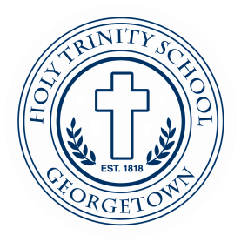

Elementary Spanish Teacher

Holy Trinity School, a Catholic elementary school in the Jesuit tradition, seeks a dynamic teacher for the 2021-2022 SY who inspires students to learn conversational Spanish. The ideal candidate will have a native or near-native proficiency in spoken and written Spanish. Classroom experience as a Spanish teacher preferred, with a demonstrated ability to inspire and support students and a willingness to work collaboratively. Candidate must show a passion about teaching and celebrating Spanish language and Hispanic cultures. A bachelor’s degree is required; a degree in Spanish or a related field is preferred.
To Apply: Send cover letter and resume to Angela Grady at agrady@trinity.org.

