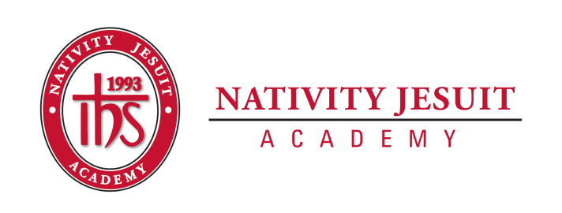
Open Position: Assistant to the President and Special Projects
Position Type: Full-Time
Equal Employment Opportunity:
Nativity Jesuit Academy is an equal opportunity employer.
About Nativity Jesuit Academy:
Nativity Jesuit Academy is a K4-8 co-ed Catholic, Jesuit, urban school serving young men and women. We prepare our students, in partnership with their families, for Christian leadership and service in high school, college, and life.
Through a holistic education program, Nativity Jesuit strives to form leaders who are religious, loving, seeking intellectual excellence, committed to justice and open to growth. Like Christ, who came “not to be served, but to serve” (Mark 10:45), Nativity Jesuit transforms students to become men and women for and with others.
Position Summary:
The Assistant to the President and Special Projects is an integral member of the administrative staff at Nativity Jesuit Academy. The role is key to support the President, Board of Trustees, and various fundraising activities of the organization.

The position reports to the President. The Assistant to the President and Special Projects works independently and as a member of the advancement team that includes the President, Director of Advancement, Assistant Director of Advancement and Advancement Coordinator to achieve organizational fundraising goals.
Position Responsibilities:
Administrative Support of the President
- Support the President in various administrative functions:
  - Manage complex calendars
  - Facilitate donor relationships
  - Coordinate and recording communications
  - Update information in our donor database
- Support the efforts of the Board of Trustees by assisting with board orientation, preparing agendas, maintaining board portal, coordinating meeting logistics, and recording minutes
- Facilitate special projects in collaboration with the President as necessary
Support of Fundraising Activities
- At the direction of the Assistant Director of Advancement, provide logistical support for event execution
- Facilitate the creation of meaningful stewardship pieces (i.e. student written thank you notes, artwork etc.) for key donors
- Maintain the grant proposal calendar in conjunction with the Director of Advancement
- Oversee routine website updates and social media postings

Position Requirements/Qualifications/Characteristics:

- Required
  - Excellent verbal and written communication skills
  - Advanced proficiency in Microsoft and Google products including performing mail merges
  - Ability to meet deadlines and achieve objectives
  - Attention to detail
  - Ability to successfully manage multiple projects and tasks
  - Motivated and able to work independently and as a team
  - Commitment to the mission, goals and objectives of the school

- Preferred
  - Bachelor’s degree
  - Experience in providing administrative support and/or communications
  - Ability to speak Spanish
  - Customer/donor database experience

How to Apply:
- Send resume to Vanessa Solis, President, at solisv@nativityjesuit.org

