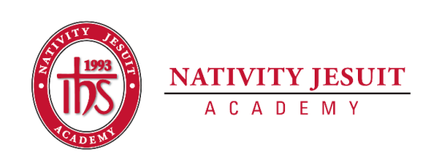
Updated March 2022

Open Position: After Care Instructor

Position Type: Full time Monday-Friday, 8:30am-5:30pm

Start Date: Immediately

Equal Employment Opportunity:
Nativity Jesuit Academy is an equal opportunity employer.

About Nativity Jesuit Academy:

Nativity Jesuit Academy (NJA) is a K4-8 co-ed Catholic, Jesuit, urban school serving young men and women in Milwaukee, WI. We prepare our students, in partnership with their families, for Christian leadership and service in high school, college, and life.

Through a holistic education program, NJA strives to form leaders who are religious, loving, seeking intellectual excellence, committed to justice and open to growth. Like Christ, who came “not to be served, but to serve” (Mark 10:45), NJA transforms students to become men and women for and with others.

Position Summary:
The After Care Instructor serves as the primary person planning, executing, and organizing the After Care program. With support from the School Program Coordinator, the After Care Instructor will work to ensure the day to day operations of the program are set up to ensure student success and safety. The position will intimately work with parents in registering for the program, creating schedules, and documenting necessary billing information. The After Care Instructor will work closely with students on a daily basis to assist with homework, help run activities, and handle discipline issues as needed. The position will support the School Program Coordinator in other extracurricular functions as available during non-student facing hours.

Position Responsibilities:
After Care Instructor duties will include but are not limited to:
- Run the day-to-day operations of the After Care program
- Assist students in the program with homework and day to day needs.
- Prepare activity materials.
- Create all student and activity schedules with approval from the School Coordinator
- Implement effective discipline procedures that have been approved by the School Coordinator
- Interactively assist all outside agencies that provide instruction or supports in the After Care program
- Execute and oversee the completion of necessary paperwork (i.e. billing, accident/incident reports, meal counts, sign-in/out, etc.)
- Support the School Coordinator with other extracurricular functions such as organizing uniforms, volunteers, and supplies.
- Perform other related duties as assigned by school administration

Position Qualifications:
- 18 yrs of age or older.
- HS Diploma or GED, preferred
- At least 1-year experience working with children, preferred.
- Enjoy working with children.
- Required Trainings
  - Current CPR/AED certification (ability to successfully complete CPR/AED, new employee only!)
  - Safe Environment training (Upon hire)
- Spanish speaking (preferred)
Skills, Knowledge, Abilities:
- Ability to problem-solve
- Ability and willingness to participate and engage children in all program activities
- Ability to communicate effectively with children (ages 4-14 years old), staff and parents
- Possess quality of patience, flexibility, understanding, acceptance, and care.
- Ability to supervise and manage groups of children following developmentally appropriate practices
- Enjoys working with children

How to Apply:
- Send resume, cover letter, and three references to Jon Nowak, Principal, at nowakj@nativityjesuit.org
In the cover letter, address the following questions:
● What influenced you to work in schools?
Applicants that do not include a resume, cover letter, and three references will not be considered a complete application and will not be reviewed.

