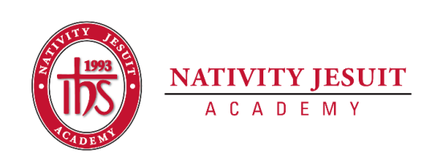
Updated October 2020

Open Position: K4-8 Physical Education Teacher

Position Type: Full Time, 10 months

Start Date: October 1, 2020

Equal Employment Opportunity:
Nativity Jesuit Academy is an equal opportunity employer.
About Nativity Jesuit Academy:
Nativity Jesuit Academy is a K4-8 coed Catholic, Jesuit, urban school serving young men and women in Milwaukee, WI. We prepare our students, in partnership with their families, for Christian leadership and service in high school, college and life.

Through a holistic education program, Nativity Jesuit strives to form leaders who are religious, loving, seeking intellectual excellence, committed to justice and open to growth. Like Christ, who came “not to be served, but to serve” (Mark 10:45), Nativity Jesuit transforms students to become men and women for and with others.

Position Responsibilities:
- Committed to the school’s mission as a Christian servant leader.
- Committed to the academic, emotional and physical growth of all students.
- Work with colleagues to ensure daily instructional curriculum meets the state teaching standards.
- Strong organization skills: effectively organize space, equipment, students and preparedness to teach assigned classes.
- Teach skills and activities that transfer into physical activities outside of the physical education classes to support the overall growth of students.
- Create structured opportunities that support maximum participation (individual, partner, small group-activities, and activities that require minimum wait-time).
- Teach engaging and challenging units of study while providing rigorous assessments.
- Ensure that all assessments are administered and graded in a timely manner; maintain accurate student records; analyze results with staff, parents, and students; make adjustments to instruction, as needed.
- Committed to all pedagogical and school culture responsibilities.
- Attend all professional development meetings and enrichment opportunities.
- Supervise and support other school day activities as assigned by supervisor.
- Complete quarterly report cards and conduct parent conferences.
- Partner with families during the school day and in other school events to build a working relationship with each family.
- Encourage and motivate all students to be active and live a healthy lifestyle in and outside of classes.
- Play a strong role alongside the school’s leadership to develop the school’s physical activity program by serving as a resource for classroom teachers and schoolwide physical activity experiences.
- Support physical education and health at the Milwaukee and Camp Thunderhead campus.

Position Qualifications/Characteristics:
- Appropriate DPI educator’s license (Physical Education, K4-8th) obtained or in the process of obtaining/transferring educator’s license.
- Minimum of a bachelor’s degree

Preferred:
- Catholic
- Spanish speaking
- Three years of relevant teaching experience

How to Apply:

Send resume, cover letter, three references to:

Vanessa Solis, Principal
solisv@nativityjesuit.org

Applicants that do not include a resume, cover letter and three references will not be considered a complete application and will not be reviewed.

