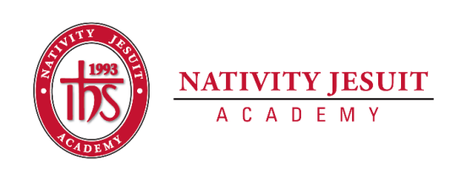
Updated October 2020

Open Position: Art Teacher: K4-8th

Position Type: Full Time, 10 months

Start Date: As Soon As Possible

Equal Employment Opportunity:
Nativity Jesuit Academy is an equal opportunity employer.
About Nativity Jesuit Academy:
Nativity Jesuit Academy is a K4-8 coed Catholic, Jesuit, urban school serving young men and women in Milwaukee, WI. We prepare our students, in partnership with their families, for Christian leadership and service in high school, college and life.

Through a holistic education program, Nativity Jesuit strives to form leaders who are religious, loving, seeking intellectual excellence, committed to justice and open to growth. Like Christ, who came “not to be served, but to serve” (Mark 10:45), Nativity Jesuit transforms students to become men and women for and with others.

Position Responsibilities:
- Committed to the school’s mission as a Christian servant leader.
- Strong organization skills and preparedness to teach assigned classes.
- Work with colleagues to ensure daily instructional curriculum meets the state teaching standards.
- Teach engaging and challenging units of study while providing rigorous assessments.
- Extensive knowledge and interest in various art forms and the history of their development.
- Diversified knowledge of various forms of art (digital arts, photography, printmaking, cinematography, calligraphy, jewelry designing and fashion, etc.)
- Patience and approachability so that students feel comfortable to express themselves.
- Attend all professional development meetings and enrichment opportunities.
- Ensure that all assessments are administered and graded in a timely manner; maintain accurate student records; analyze results with staff, parents, and students; make adjustments to instruction, as needed.
- Committed to all pedagogical and school culture responsibilities involved with implementing blended learning.
- Complete trimester report cards and conduct parent conferences.
- Partner with families during the school day and in other school events to build a working relationship with each family.

Position Qualifications/Characteristics:
- Appropriate DPI educator’s license obtained or in the process of obtaining/transferring educator’s license
- Minimum of a bachelor’s degree

Preferred:
- Catholic
- Spanish speaking
- Three years of relevant teaching experience

How to Apply:

In the cover letter, address the following:
- What is your teaching philosophy when it comes to fostering a love for art?
- What factors do you think most contribute to student success?
- Address relevant experience

Applicants that do not include a resume, cover letter and three references will not be considered a complete application and will not be reviewed.

