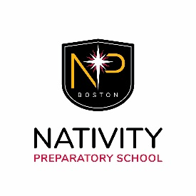
Nativity Prep Teaching Fellowship
Application Process and Timeline
- We will review applications on a rolling basis until this position is filled. Interested candidates are therefore encouraged to fill out the online application (https://www.nativityboston.org/teaching-fellowship/) as soon as possible.
Responsibilities
- Two-year commitment to Nativity Prep
- Live in community with other fellows at Burton House
- Teach (or co-teach) two classes
- Serve as an advisor to 3-4 students
- Supervise school-day activities (~2 periods per day, Monday-Friday)
- Supervise afternoon activities from 3:30-5 p.m. (Monday-Thursday)
- Supervise evening study from 5-7:30 p.m. (Monday, Tuesday, or Wednesday)
- Coordinate other school programs (e.g., serving as liaison to Boston College PULSE tutors) as assigned by the principal
Compensation
- Room and board at Burton House (in Jamaica Plain)
- Medical and dental insurance
- $500/month stipend
- AmeriCorps Educational Award
- Access to school-owned vehicles for local transportation
- Opportunity to enroll tuition-free in a master’s degree program at the Boston College Lynch School of Education
- Chance to make a difference in the life of a Nativity Prep student

Please visit the Teaching Fellowship page of our website for more information and to fill out an application:
https://www.nativityboston.org/teaching-fellowship/

