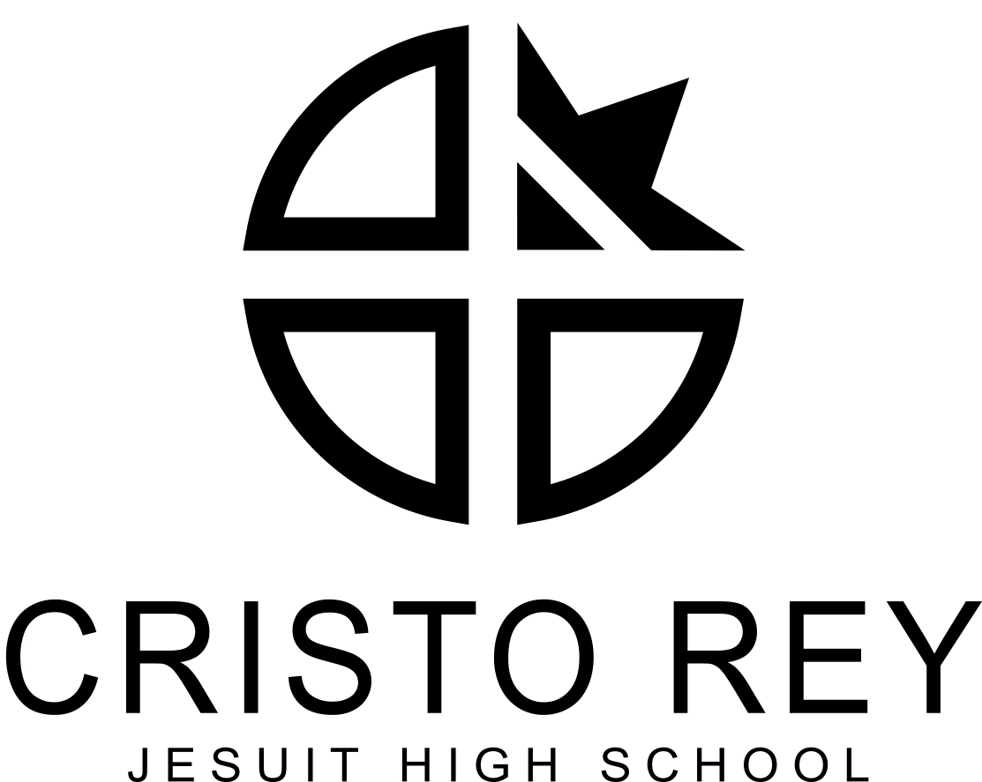

CRISTO REY JESUIT HIGH SCHOOL – TWIN CITIES

POSITION DESCRIPTION
www.cristoreytc.org

Position: Teacher of General Science (High School)
Reports To: Principal
Location: 2924 4th Ave S., Minneapolis, MN 55408
Beginning: 2019-2020 School Year
FTE/Classification: Full-Time, Contract

School Description:
Cristo Rey Jesuit High School is a private, Catholic, college-prep high school sponsored by the Society of Jesus (Jesuits), serving students of diverse backgrounds from under-resourced families who live in the greater Twin Cities metropolitan area. The mission of the Cristo Rey Jesuit High School-Twin Cities is to provide an education in the Jesuit tradition which integrates college preparatory academic and professional work environments thereby preparing students from under-resourced families for success in college and life. All students are required to complete a standards based promotion, literacy and numeracy first, college preparatory curriculum and participate in the Corporate Work Study Program whereby each student works five days per month in a corporate work assignment. Cristo Rey Jesuit High School – Twin Cities is a member of the Cristo Rey Network of 35 high schools around the United States that subscribe to similar demographic, academic, and internship program guidelines. See www.cristoreynetwork.org.

Essential Duties and Responsibilities

Responsibilities:
Instructional Practice
- Guided by the Cristo Rey Network’s standards and benchmarks, develop standards-based, data-driven annual, unit, and lesson plans that drive student-achievement gains on core assessments, including Cristo Rey Network end-of-course assessments.
- Design and administer interim assessments aligned to course standards, complete in-depth analysis of student performance on them, and design appropriate instructional responses to assessment results.
- Implement rigorous, engaging, high-impact lessons that accelerate student growth and differentiate for individual students.
- Provide targeted one-on-one and small-group tutoring to students outside of regular class time.
- Actively build an understanding of each student as an individual in the spirit of cura personalis (care for the whole person).
- Help define, and consistently uphold, school-wide practices, routines, and norms for student behavior including PBIS (positive behavior interventions and support) and High Trust philosophies.
- Maintain a classroom culture that supports student learning.
- Reflect on teaching practices through regular coaching meetings guided by the Danielson Framework for Teaching

Professional Presence
- Participate in continued professional development.
- Participate actively in the professional community through collaboration with colleagues in a range of contexts.
- Contribute to the Cristo Rey community outside of classroom responsibilities.
- Partner with the full Cristo Rey community to further the mission as a college preparatory school.
- Model values consistent with Catholic, Jesuit education and service to others.
Other responsibilities and duties as assigned by the Principal

Qualifications and Requirements:
Required:
- Bachelor’s degree with a major, minor, or comparable credential of content expertise in the primary teaching discipline (science)
- Proficiency using technology to advance teaching and learning
- Knowledge of best practices in the teaching and learning of science
- Competency in designing and implementing curricula to serve a heterogeneous student population diverse in culture, religion, and ability
- Commitment to the mission of Cristo Rey Jesuit High School
- Complete Virtus training, sign a Code of Conduct, and pass a background check

Preferred:
- Teaching license in the primary teaching discipline
- Master's Degree in Education or content area
- Prior successful inner-city high school teaching experience
- Experience with teaching students in need of significant academic support
- Ability to speak another language
- Experience working with English language learners
- Demonstrated ability to collaborate with colleagues effectively

Please complete our online faculty application form to apply for this position: https://www.cristoreytc.org/apps/form/facultyapp

