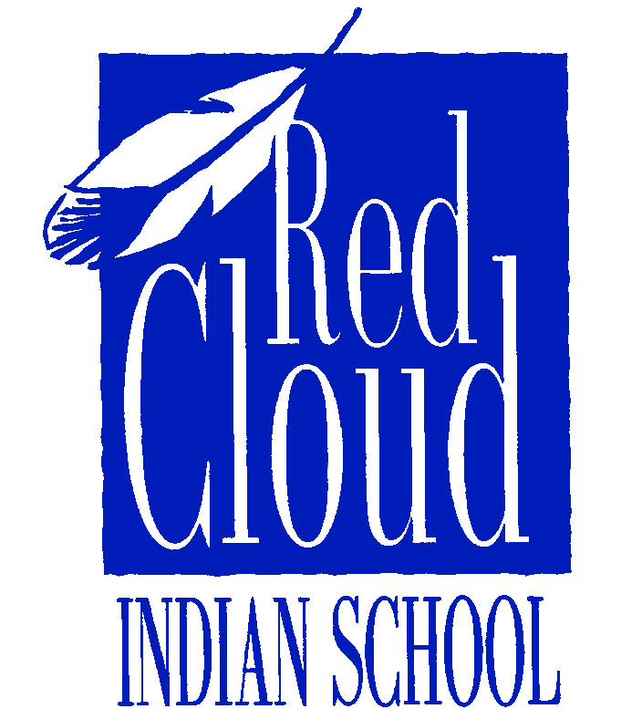

Leadership Gift Officer
Red Cloud Indian School

Department: Advancement
Supervisor: President or Chief Advancement Officer
Status: Full-time
Full-Time Classification: Exempt ______________________________________________________________________________

The mission of Red Cloud Indian School, a Catholic Institution administered by the Jesuits and the Lakota People, is to develop and grow as a vibrant Church, through an education of the mind and spirit that promotes the values of the Lakota Culture. We strive to educate both the minds and the hearts of the 600 Lakota students we serve, developing the Lakota leaders of tomorrow who will become agents of social change on the Pine Ridge Indian Reservation. Additionally, we minister to the needs of the students’ families through ten churches across the Reservation, and we provide cultural education, heritage tourism, and economic development through a vast collection of Native art at The Heritage Center.

Position Summary: Red Cloud Indian School is seeking to fill the position of Leadership Gift Officer at a time of unprecedented growth in the organization’s advancement efforts. Currently, we are quietly moving through a multi-year campaign to provide programmatic and capital improvements and endowment security for Red Cloud Indian School so that the impact that is being provided today will be available for future generations.

The Leadership Gift Officer will be responsible for continuing to solicit funding toward meeting the institution’s approximately $14 million in annual operating expenses, while simultaneously supporting efforts to meet the campaign’s goals. The Leadership Gift Officer will be instrumental in continuing to develop a solid framework for the future stability of the organization’s major gift effort with individual donors who gift $5,000-$25,000 annually. Person will also strategically examine our extensive database of donors to determine best prospects to lift to this level.

Central to the role will be educating prospects about Red Cloud Indian School, engaging them, and soliciting their partnership through an active schedule of visits and events. Nationwide travel is required with donors heavily concentrated in Boston, New York, DC, Milwaukee, Chicago, Omaha, Los Angeles, San Francisco, and other locations.

This position will work in tandem with staff who solicit larger and smaller gifts as part of Red Cloud’s Leadership Society. They will work most closely with the President and other advancement staff to align strategy and operations of their work. They will also interface with members of the Board of Trustees and other key constituents to build the network of support.

The ideal candidate for this position has a proven track record in strategic fundraising, understands the needs and interests of individual donors, and is a sophisticated, passionate communicator, committed to going out and getting gifts over $5,000.

Principal duties:
- Work closely with Red Cloud’s President and Chief Advancement Officer and others in Leadership to create and carry out strategies and departmental goals for solicitation and stewardship of an active portfolio of high net worth individuals. This will include a portfolio of 150+ major givers and their proactive cultivation, solicitation and stewardship activities, integrating support requests into long-term relationship strategies.
- Travel extensively, communicating to donors and prospects a strategic understanding of Red Cloud Indian School’s priorities and projects, maintaining familiarity with education, social justice, and arts issues.
- Set and monitor annual revenue targets for major gifts, developing regular updates on institutional donor revenue for leadership and Board of Directors.
- Prepare Red Cloud senior staff for key meetings and donor cultivation.
- Make numerous decisions on cultivation time committed vs. expected gift response, determine key participants in prospect and donor relationships and decide the most effective and productive use of travel time to achieve annual fundraising goals.
- Further develop ways and implement a system to identify major and planned gifts
- Make timely and effective use of Red Cloud’s records management resources to ensure appropriate records management of donors and prospects, developing regular updates.
- Perform miscellaneous job-related duties as assigned.
- Research, write, edit, and oversee the preparation of persuasive and accurate solicitations, correspondence and other materials communicating to donors and prospects reflecting a strategic understanding of Red Cloud Indian School’s priorities and projects

Desired Knowledge and Experience:
- Bachelor’s degree or higher. Master’s preferred.
- At least three years of progressive experience in cultivating and soliciting individual gifts. Demonstrated success in donor solicitation, gift closing and stewardship.
- Able to initiate, analyze, monitor, evaluate and advance strategic advancement plans.
- Demonstrated leadership and the ability to successfully manage and operate with multi-functional or diverse areas.
- Excellent communication and writing skills: ability to gather understand and synthesize information from a variety of sources and articulate the organization’s mission, program objectives, and resource needs persuasively to potential donors.
- Strong strategic, analytical and project management skills with a demonstrated ability to take primary responsibility for a diverse number of projects and to complete them in a timely manner with limited supervision.
- Knowledge of tax laws that impact charitable giving, personal assets and estates, including options and benefits related to planned giving vehicles.
- Creative and entrepreneurial with strategic problem-solving skills.
- Superb networking, teamwork and interpersonal skills with the ability to work effectively with multiple, culturally diverse stakeholders.
- High level of maturity and motivation, with a firm commitment and ability to develop high quality and time sensitive work products and prioritize major donor prospects.
- Able to nurture, empower, and work effectively with diverse members of the staff of Red Cloud Indian School.
- Previous experience in education, museums, and/or social justice and strong dedication to Red Cloud’s mission.
- Excellent computer skills, including Microsoft Office and Google products and project management databases, and 2-3 years of experience with The Raiser’s Edge.

Ideally person hired would live on Red Cloud campus or close by – but they could live elsewhere, and come to Red Cloud four times per year.

To apply, interested candidates should submit the following materials:

- Cover letter expressing interest in Red Cloud Indian School, aligning your skills and experiences to your understanding of the position
- Current resume with all dates included
- Description of previous campaign work and responsibilities
- A copy of Red Cloud’s employment form found online

Given the nature of this position – questions and inquiries can be made to: Michael Welch, michaelwelch@redcloudschool.org

***

Please submit your completed application by May 17 to:

Director of Human Resources
Red Cloud Indian School
100 Mission Drive
Pine Ridge, SD 57770
lisaswallow@redcloudschool.org

www.redcloudschool.org/staff/Careers
Red Cloud Indian School is an Equal Opportunity Employer.

